33.37: The velocity vector “maps out” the path of the light beam, so the geometry as shown below leads to:
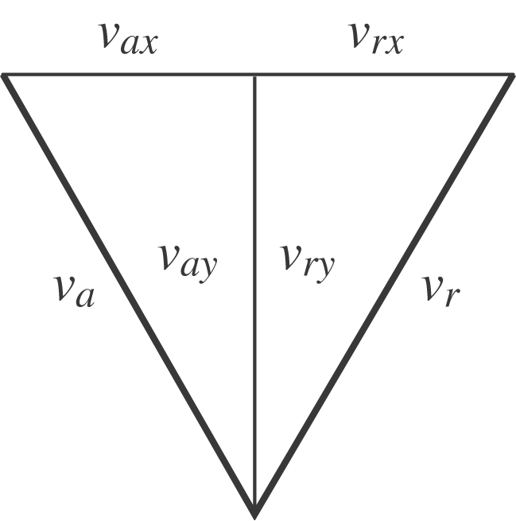

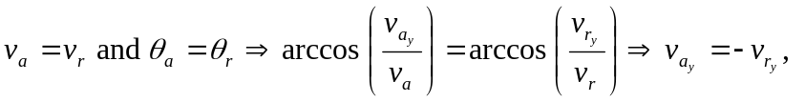with the minus sign chosen by inspection. Similarly,